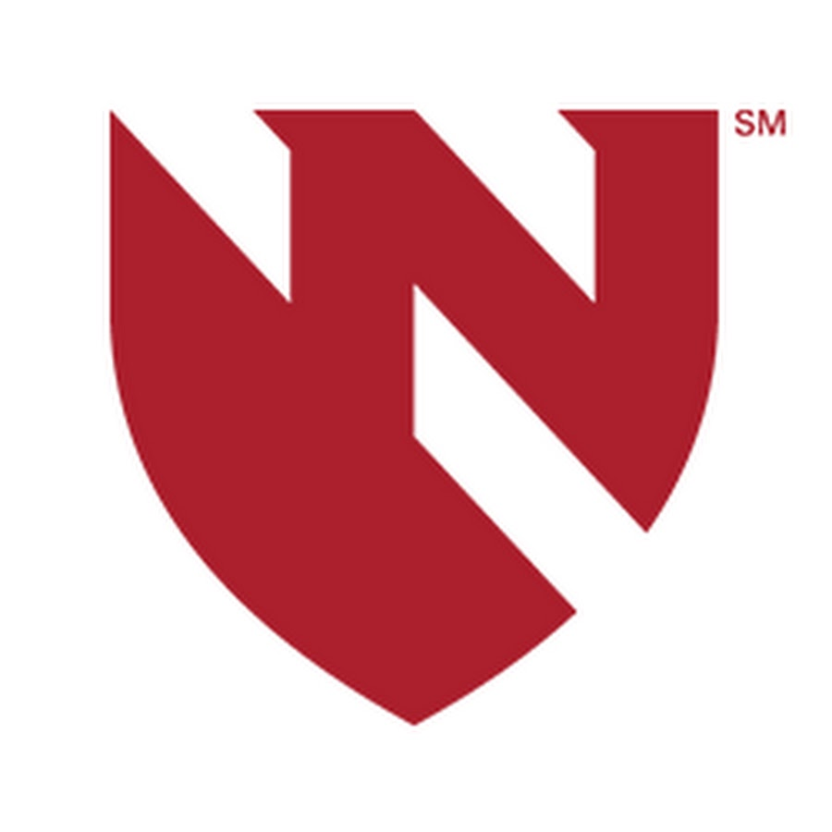
NEW INVENTION NOTIFICATION (NIN)
Nebraska Medicine

Invention Disclosure Form

General Instructions

The purpose of this New Invention Notification (NIN) form is to generate a written, dated record of your invention and to provide information from which the patent potential and commercial potential of your invention can be evaluated. Please review the following information before completing the attached form.
- The NIN form is in Microsoft Word format and may be downloaded from the UNeMed website (www.unemed.com). Once completed, please return a copy signed by all inventors to UNeMed (electronic signatures and submission are acceptable).
- A New Invention Notification should be completed when something new and useful has been conceived or developed, or when unusual, unexpected or unobvious research results have been achieved and can be utilized.
- Identifying all individuals who contributed to the conception or development of the technology is very important. Please note that inventorship is not the same as authorship and will be determined according to U.S. patent law when a patent application is filed. When completing this form, it is best to list the potential pool of individuals who contributed to the conception and/or development of the invention.
- To fully and properly evaluate the invention, UNeMed must receive all data supporting the invention (tables, charts, graphs, presentations, manuscripts, etc).
- UNeMed will begin its internal review upon receipt of the signed, completed NIN. Questions or requests for meetings to discuss the NIN will be directed through the Primary Contact; however UNeMed encourages all potential inventors to participate as much as possible.
- Please do your best to complete this form as much as possible. Incomplete NIN submissions may be delayed. If you have any questions, contact UNeMed at 559-2468.
- Add spaces and/or table rows as needed; otherwise do not modify the form. If a question does not apply, please mark "N/A". If for any reason the information you need to add does not fit within the boxes, please feel free to add information as an attachment as necessary.
For advice on completing this NIN or for additional information, contact UNeMed. Upon completion of the NIN, please return one (1) signed copy, along with all supporting documentation to:
UNeMed
986099 Nebraska Medical Center
Omaha, NE 68198-6099
Phone: (402) 559-2468
Email: unemed@unmc.edu
Website: www.unemed.com

1. Title of Invention: Please provide a non-confidential title.

2a. Chronology of Invention: It is important to document when the invention was conceived and reduced to practice.
 | Date (mm/dd/year) | Location and comments
Idea First Conceived
Experimental Evidence of Invention (reduced to practice)
First written description

2b. Have the Essential Elements of the Invention Been Communicated to Anyone Outside of the Group of Inventors , Either Orally or in Writing? (e.g. publication, thesis/dissertation, seminar, poster, meeting abstract, web page) Public disclosure of your invention prior to filing a patent application is likely to result in the loss of patent rights in foreign countries. The United States provides for a one-year grace period for the filing of a patent application following public disclosure. Please list any disclosures (including Nebraska Medicine presentations) which described the invention.
If Yes, please specify (e.g. date, name, circumstances).
 | Yes |  |  | No

2c. Do you Intend to Publicly Communicate the Essential Elements of the Invention in the Future, Either Orally or in Writing?
If Yes, please specify planned date of disclosure.
 | Yes |  |  | No

3a. Provide a Non-confidential, Simple and Commercially Applicable Summary of the Invention. (This information will largely support marketing evaluation. Please include advantages, characteristics and industry applications.)

3b. Detailed Description of the Invention: If necessary, additional descriptive information may be added as an appendix (e.g. data charts, graphs, publications, abstracts, grant applications, presentations).

3c. What Are the Practical and Commercial Applications of the Invention? (i.e. what problem does it solve?)

3d. What Are the Advantages of Your Invention Over Currently Available Technologies? (i.e. what technology is currently used to meet this need and how is your technology better?)

4. Funding Sources: Please list all funding sources for materials, equipment and/or salaries of all personnel involved in conception and development of the invention.
Funding Source | Name of Department, Company, Agency etc. (e.g. NIH, DOD, AHA, JDRF) | Grant number | Award Date
Federal/Other Government Funds
Corporate/Industrial
Private/Public Foundation (e.g. AHA)
University/Departmental
Others (Please Specify)
If Federal Funds, provide the PI’s department grant administrator contact info:

5. Did This Invention Utilize Outside Sources of Materials or Confidential Information: Please list all agreements (e.g. MTA, CDA, consulting, contracts) involved in conception and development of the invention.
Source | Materials/Information | Type of Agreement and Date

6. Please List any Companies You Find Are/Might Be Interested in Your Invention. (Specific contacts are most helpful).
Name of Company | Contact Information

7. List any known pre-existing technology which your invention derives from, integrates or otherwise would be required to utilize. If none, click here:

8. Inventor Identification: Please include all potential inventors, including collaborators from other institutions outside Nebraska Medicine. (We will consult with the Primary Contact on whether and how best to contact any outside potential inventors.)

ALL POTENTIAL INVENTORS AFFILIATED WITH NEBRASKA MEDICINE DURING THE CONCEPTION AND DEVELOPMENT OF THIS INVENTION MUST SIGN BELOW. BY SIGNING THIS NEW INVENTION NOTIFICATION FORM YOU HEREBY ASSIGN YOUR RIGHTS IN THIS INVENTION TO NEBRASKA MEDICINE.
To the best of my knowledge all statements and information provided in this New Invention Notification (NIN) form are true and complete. I understand and agree that all rights, obligations, and financial interests pertaining to or derived from the invention are as determined under my employment agreement with Nebraska Medicine as well as all relevant Nebraska Medicine policies. I also understand and acknowledge that Nebraska Medicine has the right to change its policies from time to time, including the percentage of net royalties paid to me. Further, I acknowledge that the percentage of net royalties paid to inventors is derived only from consideration in the form of money or equity received under a license, option, or material transfer agreement for licensed rights. Any conflict of interest will be handled according to specific Nebraska Medicine policies which may require disclosure of a personal interest in the form of potential revenue through commercialization of an invention described in a publication or presentation. I agree to assist Nebraska Medicine and UNeMed in the evaluation, possible protection and commercialization of the invention as described in this NIN.

Primary Contact
Name:
Citizenship:
Home Address:
Work Address:
Phone: | Fax:
E-mail:
Department:
Affiliations in addition to Nebraska Medicine (All that apply):
UNMC UNL UNO UNK VA
Non Nebraska Medicine Inventor (please specify):

Signature:

Additional Inventors
Name: |  | Name:
Citizenship: |  | Citizenship:
Home Address: |  | Home Address:
Work Address: |  | Work Address:
Phone: | Fax: | Phone: | Fax:
E-mail: |  | E-mail:
Department: |  | Department:
Affiliations in addition to Nebraska Medicine (All that apply):  UNMC UNL UNO UNK VA  Non Nebraska Medicine Inventor (please specify): |  | Affiliations in addition to Nebraska Medicine (All that apply):  UNMC UNL UNO UNK VA  Non Nebraska Medicine Inventor (please specify):
Signature: |  | Signature:

Additional Inventors
Name: |  | Name:
Citizenship: |  | Citizenship:
Home Address: |  | Home Address:
Work Address: |  | Work Address:
Phone: | Fax: | Phone: | Fax:
E-mail: |  | E-mail:
Department: |  | Department:
Affiliations in addition to Nebraska Medicine (All that apply):  UNMC UNL UNO UNK VA  Non Nebraska Medicine Inventor (please specify): |  | Affiliations in addition to Nebraska Medicine (All that apply):  UNMC UNL UNO UNK VA  Non Nebraska Medicine Inventor (please specify):
Signature: |  | Signature:

Name: |  | Name:
Citizenship: |  | Citizenship:
Home Address: |  | Home Address:
Work Address: |  | Work Address:
Phone: | Fax: | Phone: | Fax:
E-mail: |  | E-mail:
Department: |  | Department:
Affiliations in addition to Nebraska Medicine (All that apply):  UNMC UNL UNO UNK VA  Non Nebraska Medicine Inventor (please specify): |  | Affiliations in addition to Nebraska Medicine (All that apply):  UNMC UNL UNO UNK VA  Non Nebraska Medicine Inventor (please specify):
Signature: |  | Signature:

If more space is needed to identify all potential inventors, please provide the above information for each additional individual in an attachment.

